EXPT NO:6B | DATA VISUALIZATION USING POWER BI (ADVANCED SALES ANALYTICS)

Aim:

To load the Student Performance Factors dataset into Power BI, transform the data, create calculated measures, and visualize student academic performance to obtain meaningful insights.

Algorithm:
ALGORITHM 1: IMPORTING DATA INTO POWER BI
Step 1: Open Power BI Desktop.
Step 2: Select:
Home → Get Data → Text/CSV
Step 3: Browse and select:
StudentPerformanceFactors.csv
Step 4: Click Load.
Step 5: Verify the imported table and its columns.

ALGORITHM 2: DATA TRANSFORMATION USING POWER QUERY
Step 1: Select Transform Data.
Step 2: Open Power Query Editor.
Step 3: Check the dataset for duplicate records.
Step 4: Handle missing values in columns such as:
- Teacher_Quality
- Parental_Education_Level
- Distance_from_Home
Step 5: Set appropriate data types:
- Hours_Studied → Whole Number
- Attendance → Whole Number
- Previous_Scores → Whole Number
- Sleep_Hours → Whole Number
- Tutoring_Sessions → Whole Number
- Exam_Score → Whole Number
Step 6: Click Close & Apply.

ALGORITHM 3: DATA TRANSFORMATION AND PERFORMANCE CATEGORY
Step 1: Open Data View.
Step 2: Select the StudentPerformanceFactors table.
Step 3: Select New Column.
Step 4: Create a performance category:
Performance Status =
IF(
'StudentPerformanceFactors'[Exam_Score] >= 70,
"High Performance",
"Low Performance"
)
Step 5: Press Enter to create the calculated column.

ALGORITHM 4: CREATING CALCULATED MEASURES
Step 1: Select New Measure.
Step 2: Create the following measures:
Average Exam Score =AVERAGE('StudentPerformanceFactors'[Exam_Score])
Average Attendance =AVERAGE('StudentPerformanceFactors'[Attendance])
Average Study Hours =AVERAGE('StudentPerformanceFactors'[Hours_Studied])
Total Students =COUNTROWS('StudentPerformanceFactors')
Step 3: Verify the calculated measures.

ALGORITHM 5: DASHBOARD VISUALIZATION
Step 1: Open Power BI Report View.
Step 2: Add Card visuals for students, exam score, attendance and study hours.
Step 3: Add Bar/Column charts for gender and parental education.
Step 4: Add Line Chart for Hours Studied vs Exam Score.
Step 5: Add Donut Chart for Performance Status.
Step 6: Add slicers and save the Power BI dashboard.

Output:

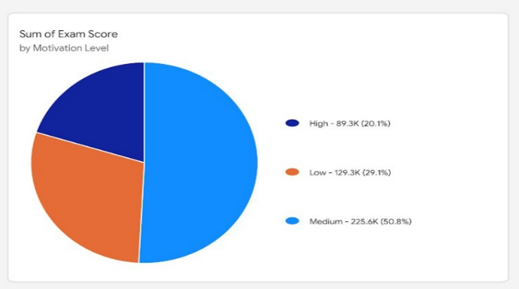
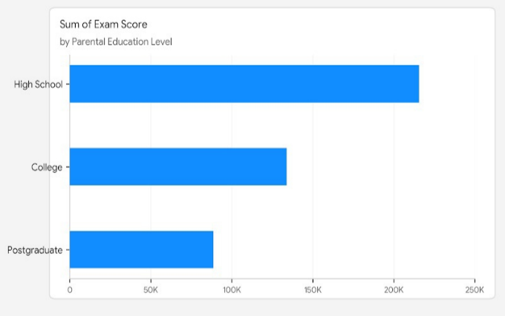

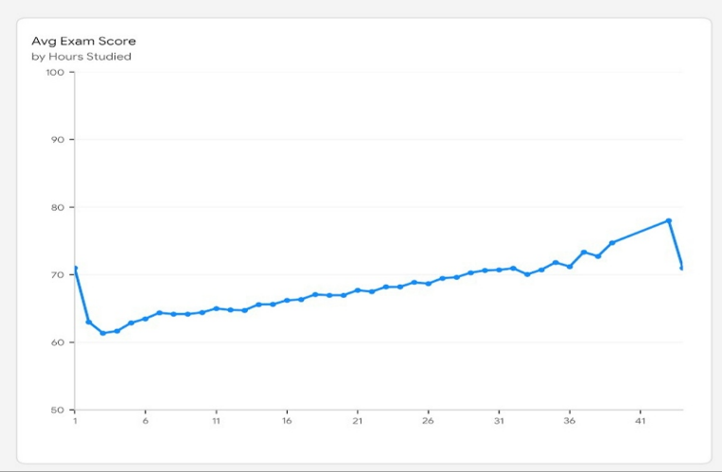

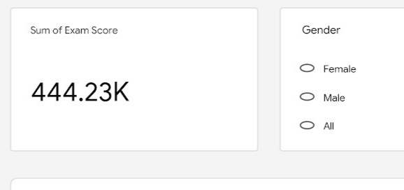

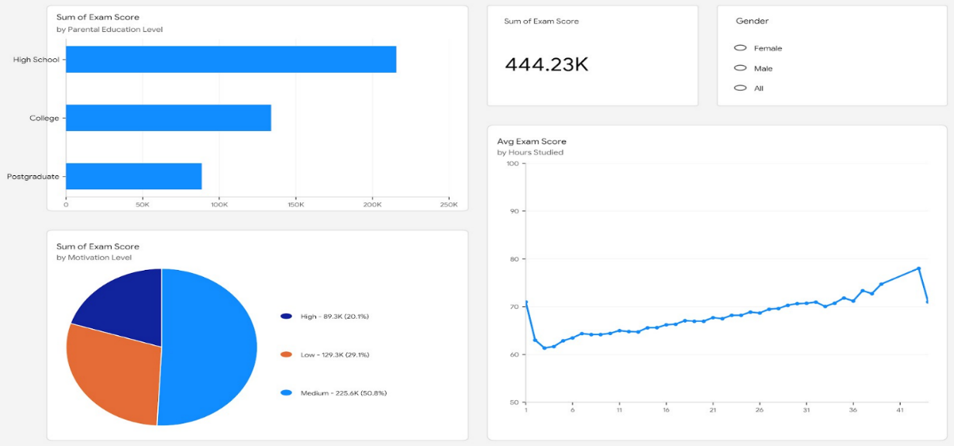

Result:

